*Documentation on*

**Employee Maintenance System**

*By:*

*Mayank Raj*

## Table of Contents

1. Abstract
2. Scope
3. Diagrams
4. Classes used:-
   1. Class Description

1. Abstract

This project is aimed at developing Online Employee Maintenance System. This is an Intranet based application that can be accessed throughout the organization and this is a web based application that can be accessed over the web. This system can be used to search for Employees based on search condition, add individual employee, modify an existing employee details and display all employee details across locations within an organization. Employees can apply for leave and the leave record will be updated and can be approved/rejected by manager. This is an integrated system that contains both the user (Employee) component and the Admin component

2. Scope

Admin:

1. Login using his/her credentials
2. Add Employee
3. Modify Employee
4. View Employee

Employee:

1. Login using his/her credentials
2. Search Existing Employees

Out Of Scope

1. Admin is not able to register in the system.
2. User cannot add itself.

## 3. Diagrams

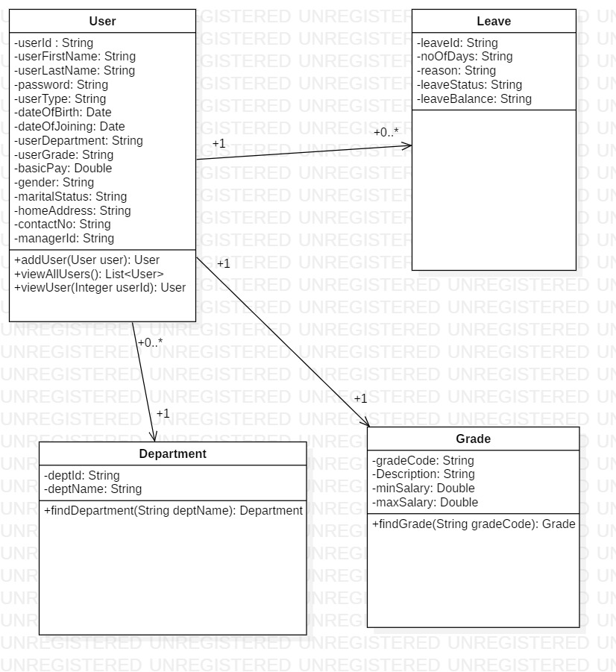

*Class Diagram*

*Use Case Diagram- Admin*

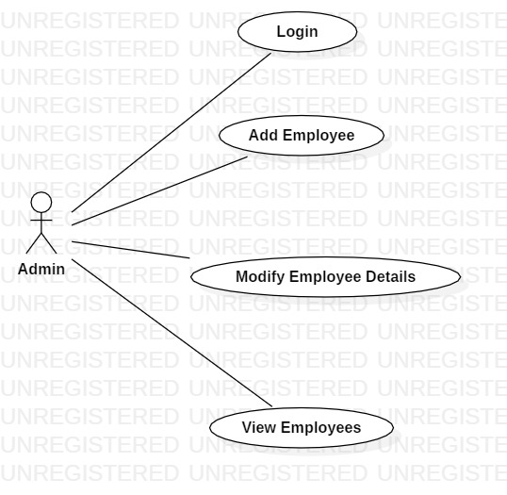

Use Case Diagram-User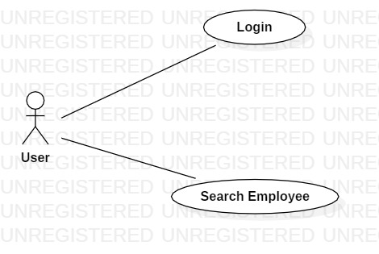

## Class Description :

## 

1. **User**: General class containing basic properties of user

Attributes:

* *userId:* Integer
* userFirstName: String;
* userLastName: String;
* Password: String;
* userType: String;
* dateOfBirth: Date;
* dateOfJoining: Date;
* userDepartment:Department;
* userGrade: Grade;
* basicPay: double;
* Gender: String;
* maritalStatus: String;
* homeAddress: String;

contactNo: String;

* leaveBalance: String;
* List<Leave> leavesList;
* managerId: String;

2. **Department**: Contains department details of user

Attributes:

1. *deptId: String*
2. *deptName: String*

3. **Grade**: user/employee grade details

Attributes:

*gradeCode: String*

*Description: String*

*minSalary: Double*

*maxSalary: Double*